Social Media
Social media is a quick and easy way to ask your network for donations! Below are a few tips and ideas for posting about your VIPink fundraising efforts.

Make sure to follow Komen on social media and tag us in your posts! @Komen

Facebook: https://www.facebook.com/SusanGKomen
X (formerly Twitter): https://twitter.com/SusanGKomen
LinkedIn: https://www.linkedin.com/company/susangkomen/
Instagram: http://instagram.com/susangkomen
TikTok: https://www.tiktok.com/@susangkomen

General Social Media Tips
- Change your social media profile photo to a photo of yourself wearing pink for the duration of the campaign.
- Announce your participation in the Komen VIPink campaign! Post a fun picture of yourself wearing pink and explain why you are partnering with Komen in the fight against breast cancer.
- Communicate how breast cancer has impacted you. Whether it’s your own personal experience or a friend or family member, every personal story will resonate with your social community and make a meaningful connection to the Komen cause.
- Use the shareable graphics with breast cancer facts to demonstrate urgency in the fight against breast cancer.
- Include a link to your personal fundraising page in your posts for donors to click to make a donation. Make sure you update your personal fundraising page with why you are involved with VIPink before you send your link out!
- Thank your donors! This is a great way to not only acknowledge your donor, but it can also remind others to support your VIPink campaign.

Social Media Graphics

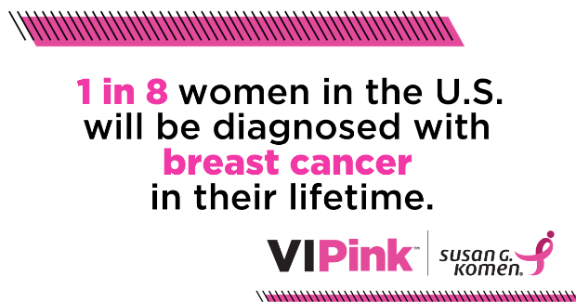 | 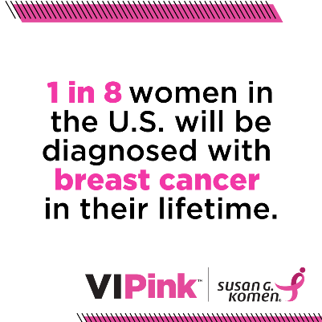
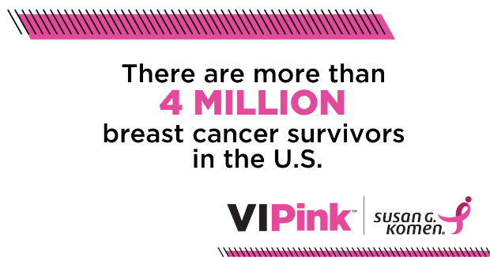 | 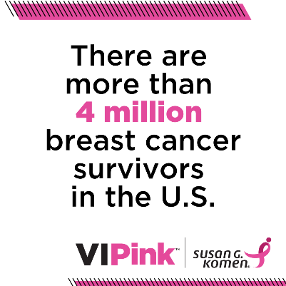
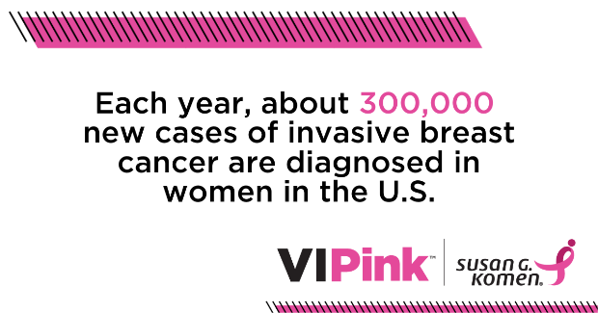 | 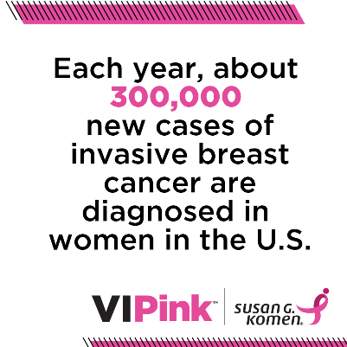

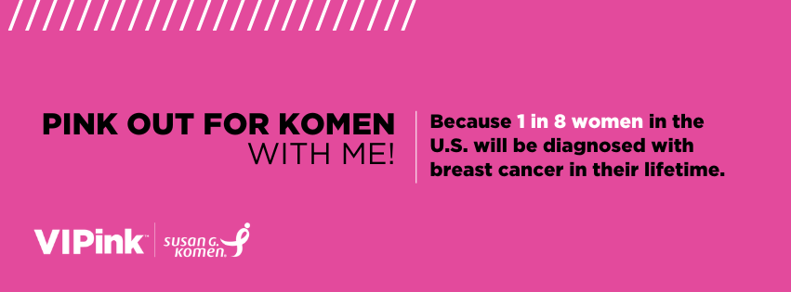
Facebook Cover Photo

Sample Social Media Posts

 | Too many people I know have been affected by breast cancer, and that’s why I’ve accepted the @Komen VIPink challenge! Not only will I wear pink, but I’ll also raise (insert amount) to help end breast cancer. Help me reach my fundraising goal:(link to personal donation page)
 | Things are starting to get real fun and REAL pink! Let’s celebrate all the amazing work @Komen is doing to help end breast cancer! Good times for a good cause – help me reach my fundraising goal to continue their wonderful work: (link to personal donation page)
 | I’m a @Komen VIPink ambassador because it’s personal for me. Please help me raise money to fund research that saves lives. I’ve committed to raise (insert amount) by (insert date). Every dollar counts. Thank you! (link to personal donation page)
 | Pink is my new favorite color! That’s because I’m a part of VIPink, raising funds for all of those affected by breast cancer. Ending cancer needs all of us, and that’s why my goal is to raise (insert amount) by (insert date). Won’t you help me reach my goal by making a donation to my fundraising page (link to personal donation page)
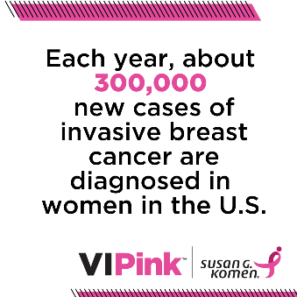 | As a VIPink ambassador I’m on a personal mission to help @Komen provide lifesaving breast care to those without insurance in our community and to help fund research to find a cure. Will you help me reach my goal? Every dollar counts! Donate here: (link to personal donation page)
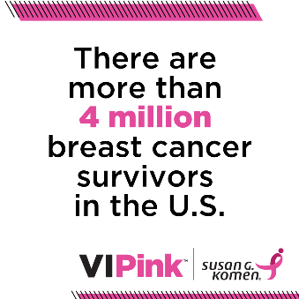 | Susan G. Komen events like VIPink make it possible for Komen to continue driving innovation and lifesaving breast cancer research. That’s just one of the many reasons why I joined this year’s campaign and set a goal to raise [Fundraising Goal]. Can you make a donation today? (link to personal donation page)
 | Every dollar makes a difference in the fight to end breast cancer. In fact, $25 could purchase supplies to help Susan G. Komen-funded researchers as they work toward finding new ways to prevent, detect and treat breast cancer. Will you help me reach my VIPink fundraising goal of (insert amount) by donating to my personal page? (link to personal donation page)
 | One more day to go! Thank you all for your unwavering support! I’m proud to say that so far, I’ve raised a total of (insert amount) to support @Komen in the fight against breast cancer. There’s still time to make your mark and help save lives! Learn more: (link to personal donation page)
 | And that’s a wrap! Thank you all for your unwavering support! I’m proud to say I was able to raise a total of (insert amount) to support @Komen in their mission to save lives and fund the cures to breast cancer. It’s never too late to show your support: link to personal donation page)

