Join Us. Save Lives.

Event Name
Date
Time
Location
RSVP details

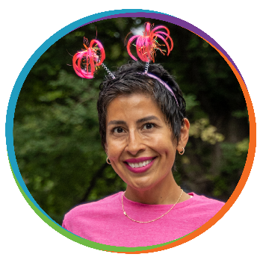


Donate to Name today by visiting http:xxxxxx

The money raised from the VIPink campaign does so much good—for those with breast cancer, for their families, for the future of breast cancer research and more—and we’re so grateful for people like you who are willing to help end this disease.
Join Susan G. Komen VIPink Ambassador, Name, for a event detail to raise funds to help end breast cancer. Name has committed to raise $5,000 for Susan G. Komen® because the women and men facing breast cancer need our support now, as much as ever. Help end breast cancer by joining us on Event Date!

